# How does weather and season affect pollution levels?

The mixing of traffic emissions can be very poor during weak wind circumstances but also strong winds can provide rapid transport to distant locations.

The rain can either clean or pollute the environment depending on harmful substances in the air[1]

Air pollution can change hourly – depending on:

* changes in weather patterns
* location
* the pollutants being emitted.

What the weather is doing can have direct effects on air quality at a given location. For example, sunshine, rain, air temperature and wind can affect the amount of air pollution present:

* Sunshine - makes some pollutants undergo chemical reactions, producing smog.
* Rain - washes out water-soluble pollutants and particulate matter.
* Higher air temperatures - speed up chemical reactions in the air.
* Wind speed, atmospheric turbulence/stability, and mixing depth - affect the dispersal and dilution of pollutants.

As the ground heats during the day the air becomes more turbulent, especially in the middle of the day. Air turbulence causes polluted air to disperse as it moves away from its source.

In contrast, stable conditions often occur at night when the air is cooler. Air contaminants released in urban areas at night, such as from home fires, are not easily dispersed causing localised air pollution.[2]

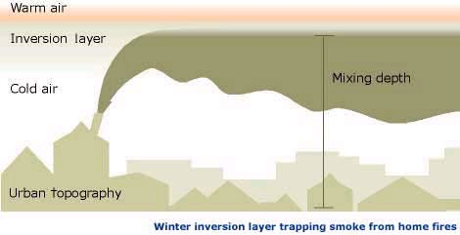

Turbulence mixes pollutants into the surrounding air. For example, during a hot summer day, the air near the surface can be much warmer than the air above. Sometimes large volumes of this warm air will rise to great heights. This results in vigorous mixing.

(basically during hot weather air pollution disperses from the source faster. inadvertently this means that during winter, pollutants stay near their source for longer.)[3]

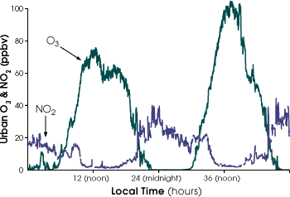

(as you can see above, during nighttime, no2 levels in urban areas is higher, because its colder and the pollutants dont mix and disperse as well.

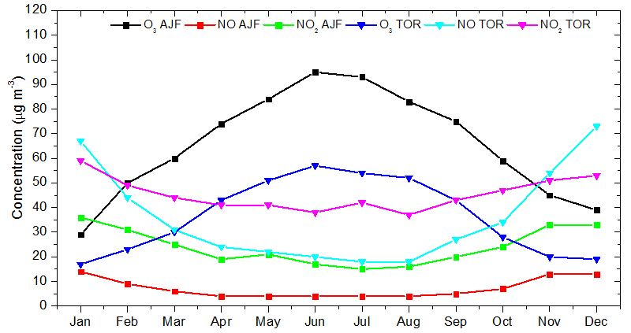[4]

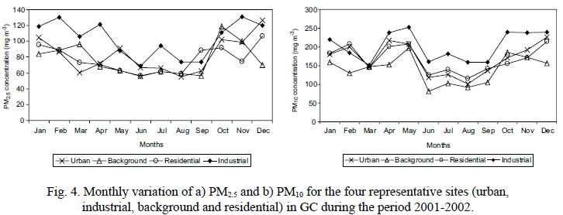

[5]

1. <http://en.ilmatieteenlaitos.fi/weather-and-air-quality>
2. <http://www.waikatoregion.govt.nz/Environment/Natural-resources/Air/Weather-affects-air-quality/>
3. <http://earthobservatory.nasa.gov/Features/ChemistrySunlight/Images/Geotrace_fig111.gif>
4. <http://www.intechopen.com/source/html/17379/media/image4_w.jpg>
5. <http://www.scielo.org.mx/img/revistas/atm/v21n2/a4f4.jpg>